**Question 1**

Carbon monoxide (CO) is a potentially fatal poison. Amongst other things, CO exposure causes anoxemia, a reduced oxygen concentration in blood. CO binds avidly to hemoglobin (Hb), to form carboxyhemoglobin, COHb. The diagram shows plots of the oxygen content of whole blood as a function of the partial pressure of oxygen. Curves are shown for normal blood, for blood containing 50% COHb, and for blood from a patient with 50% anemia (that is half the normal content of hemoglobin).

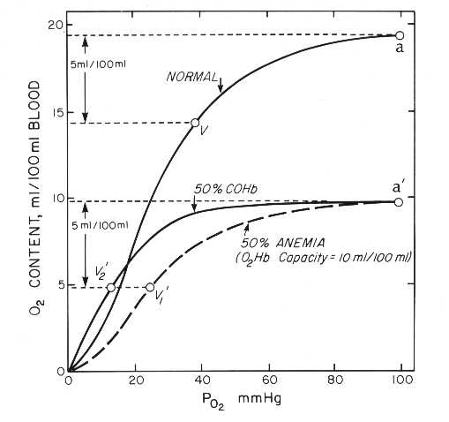

(a) Describe the **two** major differences between the oxygen binding curves for normal blood and for blood containing 50% COHb? [5 points]

**The curve for 50% COHb is shifted to the left and is less sigmoidal, and the total oxygen content of blood is reduced by half.**

(b) What is the binding site for CO in hemoglobin? [5 points]

**CO binds to the Fe ion of the heme, the same site as oxygen.**

(c) On the basis of the shape of the curve for 50% COHb, how would you best describe the mode of action of CO (based on what you have learned in class)? Bearing in mind your answer to question (b), is this description of the behavior of CO completely correct? [5 points]

**CO is behaving like an allosteric activator, since it increases the affinity of Hb for oxygen at low oxygen concentrations, and makes oxygen binding less cooperative. However, CO is not an allosteric activator in the strict sense since it binds to the same site as oxygen.**

(d) Explain the two reasons why CO restricts the delivery of oxygen to muscles.

[5 points]

**CO reduces the overall oxygen carrying capacity of blood. CO increases the affinity of oxygen binding, meaning that at the prevailing oxygen tension in muscle and other tissues, Hb gives up its oxygen less easily.**

(e) Is CO poisoning (to a level of 50% COHb) more or less severe than 50% anemia, in terms of the ability of blood to deliver O2 to tissues? [5 points]

**More severe, because oxygen binds to Hb more tightly in the presence of 50% HbCO.**

**Question 2**

Lactate dehydrogenase catalyzes the following reaction:

pyruvate + NADH lactate + NAD+

In a spectrophotometer, NADH absorbs light at 340 nm, NAD+ does not.

The **Beer-Lambert Law** relates the absorbance of a solution to its concentration, and states that:

A = .c.L

Where A is absorbance,  is the molar extinction coefficient, c is concentration, and L is the path length of the solution in the spectrophotometer. In all the calculations that follow assume L = 1 (*ie* all measurements were made in a cuvette with a 1 cm path length), so L can effectively be disregarded (although not its unit).

The molar extinction coefficient for NADH is 6,300 litres/mol cm-1 [or (mol/litre)-1 cm-1 or M-1 cm-1]. The molar extinction coefficient is the absorbance of a 1 molar solution in a 1 cm path length cuvette.

The molecular weight of NADH is 663.4.

In a 1 ml cuvette, you mix 0.1 ml of 2 mM NADH, 0.1 ml of 0.2 M pyruvate, 0.7 ml of a suitable buffer, and 0.1 ml of a solution of purified lactate dehydrogenase. You mix, place the cuvette in a spectrophotometer (with a chart recorder attached) and follow the absorbance at 340 nm. You measure a rate of decrease of absorbance (A) of 0.73 min-1. You are told that the lactate dehydrogenase solution you used in the assay contained 4.93 mg of protein per ml.

For all questions, show your calculations.

(a) How much NADH should you weigh out in order to prepare 2.5 ml of a 2 mM solution? [5 points]

**3.3 mg**

(b) Calculate the rate of production of lactate in this assay, in units of micromoles/min [Tip: you need to consider the reaction volume] [10 points]

**calculate the rate of NADH consumption:**

**c = A/**

**c = A/**

**= 0.73/6300**

**= 0.000116 moles/L/min**

**the reaction volume is 1 ml, therefore the rate of consumption of NADH in the reaction = 0.000116/1000**

**= 0.116 micromoles/min**

**Understand that the rate of lactate production is equal to the rate of NADH consumption**

(c) Calculate the **specific activity** of lactate dehydrogenase in this assay, in units of micromoles NADH oxidized/minute/mg protein. [5 points]

**The rate calculated above was catalyzed by 0.1 x 4.93 mg of enzyme = 0.493 mg**

**Therefore, specific activity = 0.116/0.493 = 0.235 micromoles/min/mg**

**For both questions, number and unit must be correct for full credit**

(d) You are provided with a second sample of purified lactate dehydrogenase, only this sample is contaminated with another protein that does not have lactate dehydrogenase activity. The total protein concentration of the sample is 7.34 mg/ml. In an assay like the one described above containing 0.1 ml of the enzyme sample you measure a lactate dehydrogenase activity of 0.143 micromoles/minute. What proportion of the enzyme sample by weight is lactate dehydrogenase, in units of %? [5 points]

**There may be several ways to solve this problem. If the sample were pure, then the expected activity would be 0.1 x 7.34 x 0.235 = 0.173 micromoles/minute. Therefore, the LDH content of the sample is 0.143/0.173 x 100 = 83%.**

**Question 3**

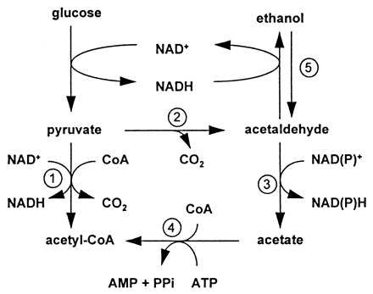

In most organisms, oxygen slows down glycolysis, and pyruvate is directed towards the TCA cycle rather than fermentative pathways (this is called the **Pasteur Effect**). Some strains of the brewers’ yeast *Saccharomyces cerevisiae* display the opposite effect, sometimes called the **Crabtree** **Effect** (or, more correctly, **glucose repression**), in which high concentrations of glucose accelerate glycolysis and the production of ethanol, even in the presence of oxygen. In other words, the organism generates ATP by fermentation even when oxygen is available. When the glucose concentration falls, the ethanol is taken back up, and it is converted to acetyl-CoA via acetaldehyde and acetate (the acetyl-CoA can then enter the TCA cycle).

1. For a yeast species that displays the Pasteur Effect, treatment with carbon monoxide accelerates glycolysis and ethanol production. That is, the yeast behaves as if oxygen is absent and now displays the Crabtree Effect. What is the explanation for this effect of carbon monoxide? [Tip: you will need to do some research on the modes of action of CO, and the enzymes of respiration]. [5 points]

**CO inhibits cytochrome oxidase and, therefore, ATP generation by respiration. The organism responds by diverting carbon towards ethanol as a way of continuing to make ATP.**

1. In humans, ethanol is metabolized by oxidation to acetaldehyde and then to acetate, by the reactions shown in the diagram. Ethanol intoxication is often accompanied by the accumulation of lactate in the bloodstream, can you suggest a reason? [5 points]

**Conversion of ethanol to acetate causes production of NADH. Reoxidation to NAD+ is coupled to oxidation of pyruvate in the lactate dehydrogenase reaction.**

(c) The subsequent conversion of acetate to acetyl-CoA (which can then be metabolized by the TCA cycle) consumes ATP. Use the diagram to suggest an alternative route from ethanol to acetyl-CoA that appears to be energetically more favorable. Why do you think this pathway does not operate? [5 points]

**Alternative route is via acetaldehyde and pyruvate. However, reaction 2 is a decarboxylation, therefore probably has a large negative delta G and so is irreversible.**

(d) In the production of wine vinegar, ethanol is oxidized to acetate via acetaldehyde by bacteria from the Genus *Acetobacter*. The production of acetate in this process requires oxygen, and an increase in oxygen availability increases the rate of acetate production. Why does acetate formation require oxygen? How does the organism make ATP? [5 points]

**Oxidation of ethanol to acetate generates NADH, which is reoxidized using oxygen as the electron acceptor. So, the organism makes ATP by aerobic respiration. Note that acetate production is not a fermentation, it is an incomplete oxidation.**

(e) Can you give two possible explanations for why some yeasts make ethanol under aerobic conditions? [5 points]

**(1) Yeast makes ethanol as a way of killing competitors. (2) This is an example of ‘overflow’ metabolism. The rate of glycolysis exceeds the cell’s ability to metabolize pyruvate by the TCA cycle and to reoxidize NADH by oxidative phosphorylation. Therefore the cell is forced to make ethanol as a means of redox balancing.**

**Question 4**

*Zymomonas mobilis* is a bacterium that was isolated from ‘pulque’, the fermenting juice of the agave. The organism is important in the commercial production of tequila. *Z. mobilis* metabolizes glucose by the Entner-Doudoroff pathway, shown below.

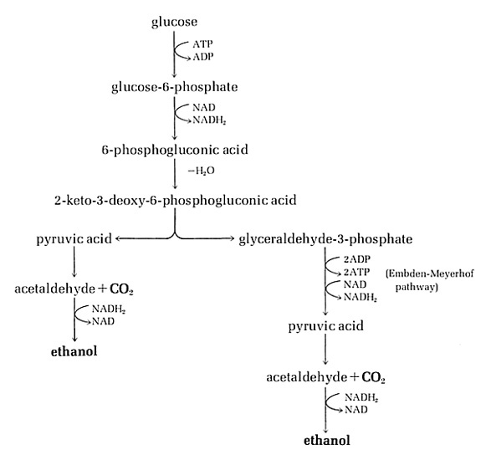

(a) What is the ATP yield of the Entner-Duodoroff pathway per molecule of glucose, and how does it compare to glycolysis? What is the NADH yield for the conversion of glucose to pyruvate, and how does it compare to glycolysis? [5 points]

**One ATP per glucose, as compared to two for glycolysis. NADH yield is 2 in both cases (though the source of NADH is not the same).**

(b) *Z. mobilis* attracts interest for the commercial production of ethanol, partly because it consumes more glucose and generates more ethanol than does yeast, per unit of biomass produced. Why does *Z. mobilis* consume more glucose and produce more ethanol than yeast? In the absence of oxygen, about how much more glucose would *Z. mobilis* require? [5 points]

**The lower ATP yield of the pathway means that *Z. mobilis* must consume more glucose per unit of biomass produced. We might predict that 2X glucose will be used by *Z. mobilis* since the ATP yield of glycolysis is 2X lower.**

(c) Cancer cells have long been known to generate energy by glycolysis and lactate fermentation (called the Warburg effect), whereas healthy cells depend upon aerobic respiration. So, tumor cells metabolize glucose around 200-fold faster than healthy cells. How might this cancer cell phenotype be exploited for the development of novel anti-cancer compounds? What are the potential drawbacks of your suggested approach? [5 points]

**Compounds that target glycolysis have potential as novel anti-tumor therapeutic agents. The danger is that such compounds will also be toxic to healthy cells.**

(d) The heterolactic acid bacteria produce lactic acid and ethanol, by the heterolactic pathway shown below.

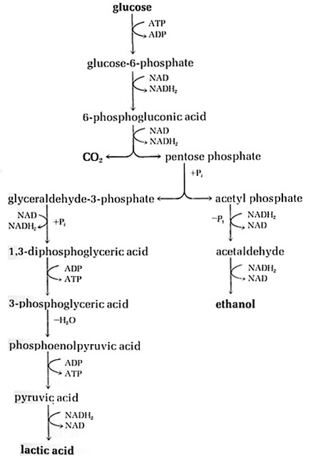

What two reactions distinguish this pathway from the Entner-Duodoroff pathway? What is the ATP yield of the heterolactic pathway? How many NADH are produced and reoxidized (per glucose) in the heterolactic pathway, and how many in the Entner-Duodoroff pathway? [5 points]

**The two steps from 6-phosphogluconic acid to glyceraldehyde-3-phosphate + acetyl phosphate distinguish this pathway. ATP yield is one. Three NAD+/NADH are turned over in this pathway, only two in the ED pathway.**

(e) You are trying to isolate a mutation in a heterolactic acid bacterium that eliminates the activity of the enzyme that converts acetyl phosphate to acetaldehyde. Do you expect this mutant to be able to grow on glucose? Explain your reasoning.

[5 points]

**No, because the pathway is not redox balanced.**